Lab 4 - Design
Ensure you rename this document to your student number before uploading to git.

Task 1 - Other Products in your market

The “How Its Made” YouTube channel -
Although different from a direct website, the How It’s made YouTube channel features 75 different videos which range from explaining how megaphones are made, to the likes of demonstrating the steps on the manufacturing process of stuffed olives.
This method of showing people how different things are made through videos may be more interesting for some people as, unlike to the likes of a website which would likely feature text backed up with pictures, videos can sometimes be easier to follow. One issue with this method is likely to be the amount of time that goes into creating each video and it also is using a third party service to post these videos via YouTube. This means that they don’t have full control over the likes of their potential customer as they will rely on YouTube to monetize their videos.

The “Made How” Website –
This website has a massive index of items and allow you to search for products through both an a-z search and in the search box in the top right of the page which allows you to search for specific pages. When going into one of the how its made pages, for example a bowling ball, the website contains a lot of text which, in this case, only contains a single picture. The page talks about; the background, History, Structural Evolution, the raw materials and the manufacturing process and links to other websites where more reading can be done. At the very bottom it offers an area for users to add contributions to the post which includes the ability to ask questions, leave their comment about the post itself and also add new information that might not already be in the post.

Task 2 - Potential customer (what do they want, make them as real as possible)

The main people using our website will be people that have an interest in vehicles. Since our idea will incorporate different types of vehicles including land, air and watercraft, it will mean that we will be able to appeal to a large range of advertisers surrounding cars.

Car manufactures -
A big potential advertiser could be the likes of car manufactures. As seen in figure 1 below, it shows an advert that would be shown on other websites that would feature cars. This shows a finance deal for a Volkswagen polo.
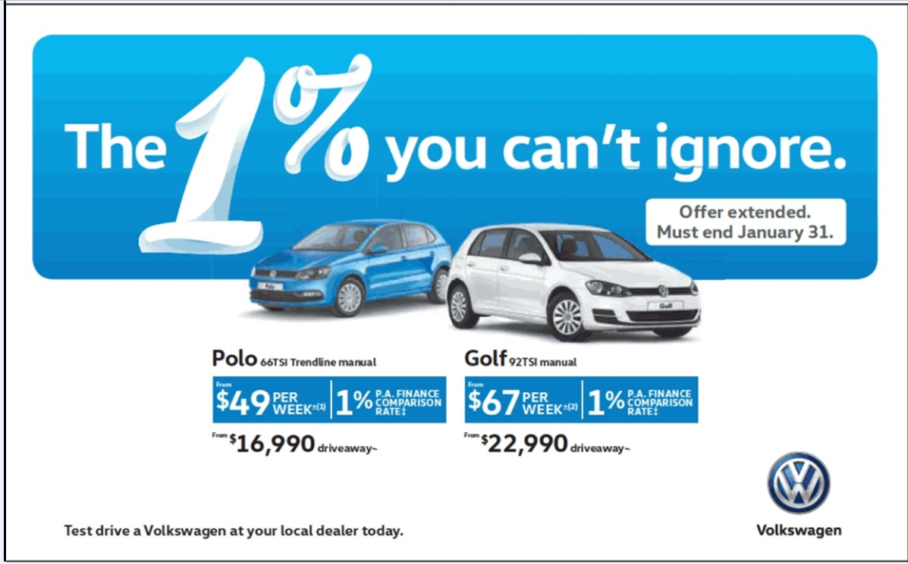 Figure 1
These are banner Ads that Volkswagen might offer themselves through direct contact or alternatively an ad Network which represent Volkswagen would be contactable to discuss monetizing our website with them. Some of the biggest advert networks are; Blogads, Chitika, infoLinks and Zedo.

Ideally, establishing a relationship with a car manufacturer directly would be the best method to monetizing our website however, it is a lot easier to get an advert network to support a startup website verses getting a large car manufacturer like Volkswagen directly to advert with us.

Insurance companies –
Along with all types of vehicles comes some level of risk. This is especially apparent for cars where, by UK law, the operator of a car must be insured with an insurance company. Although no enforced upon the likes of jet skis, it is still recommended for insurance to be taken out on them. This give potential for our website to advertise to the likes of insurance companies through the likes of google AdSense or similar services. It might also encourage insurance comparison sites like CompareTheMarket to want to advertise themselves on the website.

By people looking through our website it might suggest that they are wanting to fully research a certain vehicle before purchasing it, this may appeal to insurance companies as it means that they will be able to attract a customer into their business before that potential customer has a chance to look around other insurance websites if they think they might get a good deal with the one advertising on our website.

Task 3 - Potential end-user (fictional biography, highlight why they would care about your product)

Boat Sales Assistant – jerry, 26

Jerry’s job is renting out boats on Lough Erne for ABC boats. To attempt to appeal to the customers he’s trying to rent it out to he can look at our website which will contain a large amount of information about the boat and the history of it’s creation as it may create a lasting impression on his customers mind. He will also be able to provide them with facts about the likes of its specification from our website. By providing them with facts about the boat it may help him in completing this sale with the customer and since each time he manages to rent out a boat it creates around £2,000 in revenue for his business, every bit of assistance in his selling technique will be important and he will be able to get such information on a website like the one we plan on creating.

General public member – James, 17

James has just turned 17 and has little to no idea about cars. Although someone like James might not seem like someone who our website would appeal to however, by going on our website he will be able to read about lots of different cars. This will allow him to read about all of the different options he has for cars and find out what differentiates certain cars from others from more than just a cosmetic standpoint.
James also happens to be studying mechanical engineering at university so by having a feature on the website that would allow him to see where the nearest car factory to him is could be something to entice him into the website as he would quite like to a tour around one to get a better idea of the manufacturing process. There will also be a chat form like feature where users can leave comments so by having that facility it will mean that James might be able to get advice from people who may already have an interest in cars or alternatively speak to likeminded people alike to himself.
Task 4 - What will attract end users (reference existing products)

The “Made How” website I talked about in task two is very alike to the website we would construct. One major issue I felt there was with the Made How website was the graphic design as I felt it was very lacking and didn’t offer much polish to the overall look of the website. For the website that we will be producing I feel it would be very beneficial to include better graphic design as it would help attract an end-user in and also keep them using our website instead of going to a different service.

Another realisation I’ve came to is the fact that our website would be more unique as our website will revolve around vehicles and will mean that people will use our website for that entire field instead of us trying to cover all different types of products. It will also allow us to build up an interested end user base and from there we will a community that will hopefully help allow us to continue running the website.

Task 5 - Suggest essential & nice-to-have features (make them emotional not technical)

- Dynamic web pages (Essential) – Having dynamic webpages in our website will be an integral part of the website as it will act as a template for the rest of our website to run off and not have to create a static page for each individual record in the database.

- Integrated YouTube Player (Nice to have) – Ideally, we would like to be able to integrate a YouTube player into some of the dynamic pages, where applicable, which would allow us to let the customer read the article published by members on our forum and it would also allow the reader to watch a video on our website in case they might prefer that over reading the article.

- Find factories near you (Nice to have) – An idea that we came up with as a group was to have a feature that would inform users of where their nearest vehicle factory is in-case they would be wanting to visit the factory or see if products are locally produced. Although this is a feature we are very eager to include on our website, it is not integral to the operation of the website and the website will still be functional without it.

- Advertisements (Essential) – To have this feature in our website is an integral part as it is our source of revenue. Although our website could technically function without any advertisements, it would mean that there wouldn’t be a purpose to our website in terms of financial gain nor would there be a revenue stream to keep the website hosted.

- Login and Account creation (Essential) – Having a part of the website where users can create their own accounts and be able to contribute to posts and also to leave comments to engage with other users. By allowing other users to interact with other users so it means that there will be a community built on the website and will ensure more people stay with our website instead of going to a competitor website and encourage growth within our own.

Task 6 - Use case (A story of one of your end users first experience and feelings interacting with your website)

Why would James find the website useful
Since James is interested in learning about cars and facts about him it will mean he will be able to increase his knowledge of cars and increase his interest. Through using our website it will also allow him to chat to other people through a comment section where he will be able to ask questions and after a while may be able to answer some questions or engage in conversation with others. James will also be able to find the factories closet to him so that he might be able to visit them as he is studying mechanical engineering and feels it will also help him onward with his studies.
How James will find/hear about the website
While James is looking for information about cars our website will come up in the search results. Where our website pops up on google will become closer to the front page as our website grows in popularity which will hopefully allow the website to grow to a position where we will have a userbase where people actively submit new records and also have constant comments on the websites being made which will encourage discussions.
First page
On the first page James will be introduced to what our website is for and will be shown what the most popular records are. He will also be given a bar at the top of the website to look through different pages on the website. James will also be able to access the search bar from here.
Depending on how James comes across our website, he may be brought straight to the page regarding the record he was searching for on google which will mean he will bypass our welcome page. The webpages will all look very professional and maintain a easy to explore website. This will ensure that James doesn’t leave our website immediately to go and look at a different website for other cars.
Initial curiosity
Although James will initially come onto the website looking for information regarding cars, because of his university field of study, it is hopeful that he will then go on to read about different types of vehicles due to his interest in learning more. This will only be possible if the information that he searching for can be found within that web page or else he will find the information on a different website.
By ensuring that all of the records we have are kept updated and allowing for community discussions should enable us to make the website look more interactive and overall offer a better use facility for James.
Interaction with the website
After James sees how beneficial the website could be to him, James will make use of it a couple times and eventually he will either see something he feels should be updated or alternatively he might leave a comment which would allow him to interact with other people who use the website. To do this James would have to first create an account on the website which would enable us to keep in contact with him and will also help ensure he continues to use the website. Through creating his account he will be able to talk to other users and even start to create his own uploads on the website if his interest develops. By creating an account it will enable him to use services of the likes of the finding local factories that will only be available for members of the website to give people an incentive to sign up to the website.

James’s account will also be fully customisable which will allow him to personalise it including having the likes of a profile picture and also creating and changing his nickname on the website.

Task 7 - Minimal list of pages necessary for your team to deliver your usecases

Ryan – Ryan is responsible for creating the welcome page for the website which will contain a dynamic search bar, user submissions, links to the most popular posts and also links to the recently added records to the website.

George – George’s job is creating the dynamic pages that the records from the database will be displayed on and allowing comments to be made on posts.

Ross - Ross is responsible for creating an add/edit function to all posts. Ideally Ross would also create a “what’s made near you” webpage which would integrate google maps to locate your nearest factory’s near you however, this is a advanced feature that would be “a nice to have” instead of it being something integral to the website.

Ben – I will be responsible for the creation of user accounts and allowing them to be able to login/create accounts whenever they are anywhere in the website and also to allow the user to change any of their details. This will allow certain aspects of the website to be interacted with and will help enable certain functions on the website.

Functions like the comment section would are in the middle area of “nice to have” and “essential” as we feel like without them the website wouldn’t be as interactive and not preform as well however, the website will still be functional without them.

Upload your basic HTML page exploring your use case (see use case example document for help).

Also upload this document to you project folder (same folder containing src & httpdocs) ensuring you have renamed to your student number.

Screenshot this in your github repository and submit this to QOL by Monday.

